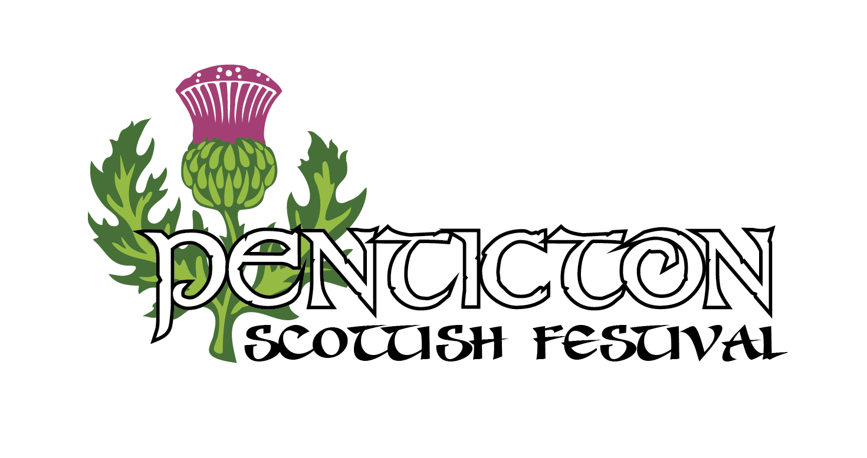
Volunteer Application Form
July 1 2017
Please complete the following information in block capitals
Personal Details
Name:

Address:
City: Postal Code:
Cell Phone: Home Phone:
Email Address:
Emergency Contact person:

Name:
Allergies:
Do you have any medical conditions?

Are you currently taking any medication that we should be aware of:

Availability
Indicate your availability below:
Friday, June 30, 9am – 12pm setup
Saturday, July 1, 6am – 9am ticket gates
Saturday, July 1, 8am – 12pm ticket gates, heavy events, grounds maint.
Saturday, July 1, 12pm – 4pm “ “ “
Saturday, July 1, 4pm – 6pm “ “ “
Sunday, July 2, 9am – 12pm tear down and volunteer appreciation BBQ

Age Group
Under 19
19 – 30
30 – 45
45 – 65
over 65
Preferred Volunteer Area
Site set-up and tear down Friday and Sunday
Site Maintenance – grounds & cleanup
Gates – selling admissions & programs,
Heavy Events Competition

Please indicate shirt size: Small, Med, Large, XL, XXL.

THERE WILL BE A VOLUNTEER ORIENTATION ON THURSDAY JUNE 29 AT 7PM AT KINGS PARK
THERE WILL BE A VOLUNTEER APPRECIATION BBQ ON SUNDAY JULY 2 AROUND 12PM AFTER TEARDOWN.
I consent that any photographs taken on the day can be used for promotion of the Penticton Scottish Festival
Signature Date

